**Term Definitions & Design Calculations for Activated Sludge Process**

**Table of Contents**

1. Design.……………………………………………………………………………………………….. p. 2

1.1 Design of Aeration Basin………….…………………………………………………….…. p. 2

1.2 Design of Secondary Clarifier.……..…………………………………………………….... p. 5

2. Determination of Volume of Concrete....…...………………………………………………………... p. 6

2.1 Concrete of Aeration Basin………….……...…………………………………………...…. p. 6

2.2 Concrete of Secondary Clarifier……..…......……………………………………………… p. 7

3. Excavation……………………………………………………………….……………………………. p.8

3.1 Excavation for Aeration Basin…………………………………………………………..…. p. 8

3.1 Excavation for Secondary Clarifier………………………..…………………………..…... p. 9

3.1 Excavation for Pump Building.……….……………………………………………….….. p. 10

4. Piping…………………………………………………………………………………………..….... p. 11

4.1 Aeration basin effluent pipes………………………………………………..……..…....... p. 11

4.2 RAS Pipes……………...………………………………………..……………………..…. p. 12

4.3 WAS Pipes...…………..…………...………………………………………..…………..... p. 12

4.4 Air Pipes………………………………………………………………………………...… p. 13

4.4.1 Air Supply Manifold……………...……………………………………………. p. 13

4.4.2 Air Headers…………………..…...……………………………………………. p. 13

4.4.3 Air Diffuser Disks………………...……………………………………………. p. 14

5. Pumping…………………………………………………………………………………………...... p. 17

5.1 RAS Pumping…..……...………………………………..…………………..……………. p. 17

5.2 WAS Pumping.………..…………...………………………………………..…………..... p. 18

5.3 Electricity Consumption...…………………………………...………..…………..….…... p. 20

6. Aeration…..…………………………………………………………………………………………. p. 20

**1. Design**

**1.1 Design of Aeration Basin**

**Parameters Needed**

|  |
| --- |
| **Flow rate, Q [m3/day]** |
| **Solids retention time, $θ_{c}$ [day]** |
| **Temperature [°C]** |

**Effect of Temperature on Parameters**

The effect of temperature on the parameters in the table below can be corrected by:

$$k_{1}= k_{2} ×{ θ}^{T_{1}-T_{2}}$$

|  |  |  |
| --- | --- | --- |
| **Parameters, k** | **Value at 20 °C** | **Temperature coefficient, $θ$** |
| **Heterotrophs** | | |
| ${\hat{μ}}_{H}$**[1/day]** | 6.0 | 1.08 |
| $b_{H}$**(1/day)** | 0.18 | 1.04 |
| $K_{S}$**[mg/L as COD]** | 20 | 1.00 |
| $Y_{H,T}$**[mg TSS/mg COD]** | 0.50 | 1.00 |
|  |  |  |
| **Autotrophs** | | |
| ${\hat{μ}}_{A}$**[1/day]** | 0.77 | 1.11 |
| $b_{A}$**[1/day]** | 0.10 | 1.04 |
| $K_{NH}$**[mg/L as N]** | 1.0 | 1.14 |
| $Y_{A,T}$**[mg TSS/mg N]** | 0.20 | 1.00 |

**Oxygen Requirement for Heterotrophs, [g O2/day]**

where

$S_{SO}$ = Influent readily biodegradable substrate concentration, [mg/L]

$X_{SO}$ = Influent Slowly biodegradable (particulate) substrate concentration, [mg/L]

$S_{S}$ = Effluent Readily biodegradable (soluble) substrate concentration, [mg/L] = 0 [mg/L] (assumption)

$f_{D}$ = Fraction of active biomass contributing to biomass debris = 0.2 (assumption)

$b_{H}$ = Decay coefficient for heterotrophs

$Y_{H,T}$ = True growth yield for heterotrophs, [mg TSS/mg COD]

$i_{O/XB,T}$ = Mass of COD per mass of biomass measure as TSS, [g COD/g TSS] = 1.2(assumption)

**Oxygen Requirement for Autotrophs, [g O2/day]**

where

$S_{N,a}$ = Influent nitrogen concentration available to the nitrifying bacteria [mg/L]

$$S_{N,a}=S_{NHO}+S_{NSO}+X_{NSO}-NR(S_{SO}+X_{SO}-S_{S})$$

$S_{NHO}$ = Influent ammonia [mg-N/L]

$S_{NSO}$ = Influent soluble organic [mg-N/L]

$X_{NSO}$ = Influent particulate organic [mg-N/L]

$NR$ = Nitrogen requirement per unit of COD removed [mg-N used/mg-COD removed]

$$NR=0.087\left[\frac{\left(1+f_{D}∙b_{H}∙θ_{c}\right)Y_{H,T}i_{O/XB,T}}{1+b_{H}∙θ_{c}}\right]$$

$S_{NH}$ = Effluent ammonia concentration [mg-N/L]

$b_{A}$ = Decay coefficient for autotrophs

$Y_{A,T}$ = True growth yield for autotrophs [mg TSS/mg COD]

**Determine If System Nitrify**

$$θ_{c, min}=\frac{K_{NH}+S_{NHO}}{S_{NHO}\left({\hat{μ}}_{A}-b_{A}\right)-K_{NH}{∙b}_{A}}$$

$$ζ_{DO}=\frac{K_{O,A}+S_{O}}{S_{O}}$$

$$θ_{c, min}=θ_{c, min} × ζ_{DO}$$

where

$S_{O}$ = DO concentration [mg/L] = 2 [mg/L] (assumption)

$K_{O,A}$ = DO half-saturation coefficient for autotrophs = 1 (Assumption)

**Total Oxygen Requirement, [g O2/day]**

If the system nitrify,

$$RO={RO}_{H}+RO_{A}$$

If the system does not nitrify,

$$RO=RO_{H}$$

**Determination of Lower Limit of Reactor Volume, [m3]**

* **Lower limit based on the mixing energy constraint to avoid floc shear, [m3]**

where

= Required airflow rate [m3/min]

RO = Oxygen Requirement [kg/hr]

$η_{Q}$ = Field oxygen transfer efficiency for diffused aeration system in percentage = 10 (Assumption)

$Π_{U,Q}$ = Upper limit on volumetric power input for diffused aeration system [m3/min-1000 m3] = 90 [m3/min-1000 m3] (Assumption)

* **Lower limit based on the maximum sustainable volumetric oxygen transfer rate, [m3]**

where RO is in [kg O2/hr]

0.10 [kg O2/m3-hr] is maximum volumetric oxygen transfer rate

* **The larger number between $V_{L, FS}$ and $V_{L, OT}$ controls**

$$V_{L, OT}=max(V_{L, FS},V_{L, OT})$$

**Determination of Upper Limit of Reactor Volume, [m3]**

* **Upper limit based on the mixing energy constraint to keep all biomass in suspension**

$$V_{U}=\frac{1000 Q_{air}}{Π_{L,Q}}$$

where

$Π_{L,Q}$ = Lower limit on volumetric power input for diffused aeration system [m3/min-1000 m3] = 20 [m3/min-1000 m3] (Assumption)

**Mass of MLSS Produced in the Reactor, $X_{M, T}∙V$ [g MLSS]**

$$X_{M, T}∙V=θ_{c} Q\left[X_{IO, T}+\frac{(1+f_{D}∙b_{H}∙θ_{c})Y_{H,T}(S_{SO}+X_{SO}-S_{S})}{1+b_{H}∙θ_{c}}\right]$$

where

$X_{IO, T}$ = Influent particulate inert material concentration [mg TSS/L]

$$X_{IO, T}=0.375 × VSS+(TSS-VSS)$$

(Assume 37.5% of the particulate organic matter is non-biodegradable)

**Solid Wastage Rate, $W_{M, T} [$ g TSS/day]**

Q in [m3/day]

in [g/m3] = [mg/L]

**1.2 Design of Secondary Clarifier**

**Parameters needed for the design of secondary clarifier:**

$X_{M_T}$ = Upper limit of MLSS Concentration [mg/L]

* Lab data (percentage removal in anaerobic filter) will be used to calculate $X_{M_T}$

**Surface Area of Clarifier Based on Average Flow Rate, [ft2]**

where = Average Flow Rate [gal/day] = $Q$

${OFR}_{avg}$ = Average Overflow Rate [gal/day-ft2] = 600 [gal/day-ft2]

**Surface Area of Clarifier Based on Peak Flow Rate, [ft2]**

where = Peak Flow Rate [gal/day] $=$ 2.5 $×{ Q}_{avg}$

${OFR}_{peak}$ = Peak Overflow Rate [gal/day-ft2] = 1400 [gal/day-ft2]

**Surface Area of Clarifier Based on Solids Loading, [ft2]**

where = Peak Solids Flow = $\left(Q_{peak}+Q_{recycle}\right) × X_{M, T} × (8.34×{10}^{-6})$

$X_{M_T}$ = Upper limit of MLSS Concentration [mg/L]

${SLR}_{peak}$ = Peak Solids Loading Rate [lb/day-ft2] = 50 [lb/day-ft2]

Unit conversion: 1 [mg/L] = $8.34×{10}^{-6}$ [lb/gal]

**Surface Area of Clarifier, [ft2]**

**Diameter of Clarifier, ${Dia}_{clfr}$ [ft]**

$${Dia}_{clfr}=\sqrt{\frac{4{ × A}_{clfr}}{π}}$$

**Side Water Depth in Clarifier, ${Depth}_{water_clfr}$ [ft]**

The side water depth in clarifier is determined by the diameter of the clarifier using the table below:

|  |  |
| --- | --- |
| **Diameter of Clarifier, ${Dia}_{clfr}$ [ft]** | **Side Water Depth, ${Depth}_{water_clfr}$ [ft]** |
| < 40 | 11 |
| 40 - 70 | 12 |
| 70 - 100 | 13 |
| 100 - 140 | 14 |
| > 140 | 15 |

**2. Determination of Volume of Concrete**

**2.1. Aeration Basin**

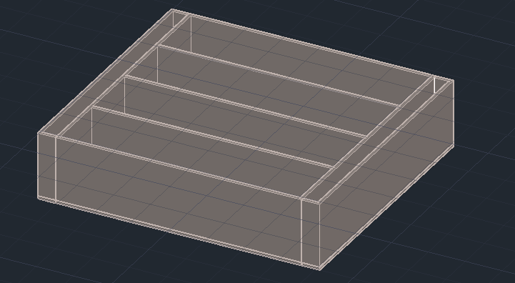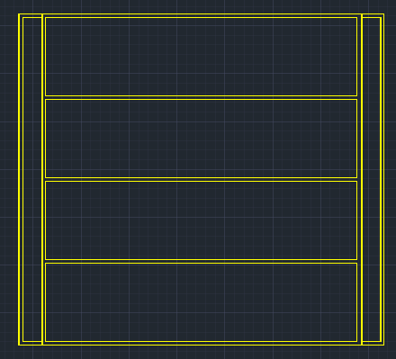

**Depth of Aeration Basin, ${Depth}_{ab}$ [ft]** = 21 [ft].Water depth is 19 ft, and freeboard is 2 ft.

**Width of Aeration Basin, ${Width}_{ab}$ [ft]** = 20 [ft].

**Length of Aeration Basin, ${Length}_{ab}$ [ft]**

${Length}_{ab}=V_{ab}/({Depth}_{ab} × {Width}_{ab} × N)$

where $V_{ab}$ = Total volume of aeration basin [ft3]

= Number of aeration basins (trains)

**Wall Thickness, $t_{wall_ab}$ [ft]**

$t_{wall_ab}$ = 1 [ft] (for ${Depth}_{ab}≤$ 12 [ft])

$t_{wall_ab}$ = ${1+(Depth}_{ab}-12)/12$ (for ${Depth}_{ab}>$ 12 [ft])

**Slab Thickness, $t_{slab_ab}$ [ft]**

$$t_{slab_ab}=t_{wall_ab}+2/12$$

**Width of N Trains, $W_{N_train}$ [ft]**

$$W_{N_train}=N ×{ Width}_{ab}+\left(N+1\right) × t_{wall_ab}$$

**Volume of Wall Concrete, [ft3]**

**Volume of Slab Concrete, [ft3]**

**2.2 Secondary Clarifier**

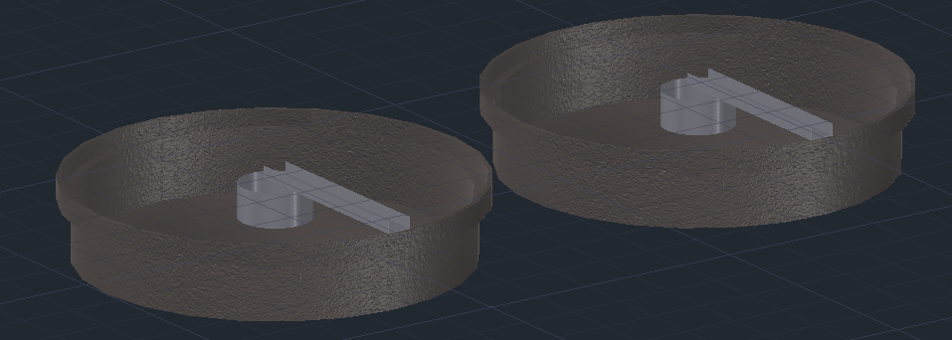

**Depth of Clarifier, ${Depth}_{clfr}$ [ft]**

$${Depth}_{clfr}={Depth}_{water_clfr}+{freeboard}_{clfr}$$

where ${Depth}_{water_clfr}$ = Side Water Depth in Clarifier [ft]

${freeboard}_{clfr}$ = Distance between water level and top of reactor [ft] = 2 [ft]

**Wall Thickness, $t_{wall_clfr}$ [ft]**

$t_{wall_clfr}$ = 1 [ft] (for ${Depth}_{ana}≤$ 12 [ft])

$t_{wall_clfr}$ = ${1+(Depth}_{clfr}-12)/12$ (for ${Depth}_{ana}>$ 12 [ft])

**Slab Thickness, $t_{slab_clfr}$ [ft]**

$$t_{slab_clfr}=t_{wall_clfr}+2/12$$

**Volume of Wall Concrete, [ft3]**

Where = Inner diameter of clarifier [ft]

**Volume of Slab Concrete, [ft3]**

where = Side length of the bottom cone shape [ft] = $\sqrt{{{height}_{cone}}^{2}+{{Dia}_{clfr}}^{2}}$

${height}_{cone}$ = Height of the bottom cone shape [ft] = $\frac{1}{12} × {Dia}_{clfr}/2$ (assume slope 1:12)



**2.3 Total Volume of Concrete, [ft3]**

**3. Excavation**

**3.1 Excavation for Aeration Basin**



**Slope of Excavation, slope [dimensionless]** = 1.5 (assumption)

**Freeboard of Excavation, freeboard [ft]** = 3 [ft] (assumption)

**Bottom Area of Excavation for Aeration Basin, [ft2]**

**Top Area of Excavation for Aeration Basin, [ft2]**

**Volume of Excavation Aeration Basin, [ft3]**

**3.2 Excavation for Secondary Clarifier**

The Excavation for secondary clarifier is shown in the figure below:



**Slope of Excavation, slope [dimensionless]** = 1.5 (assumption)

**Construction Access, access [ft]** = 3 [ft] (assumption)

**Bottom Area of Excavation for Clarifier, [ft2]**

**Top Area of Excavation for Clarifier, [ft2]**

**Volume of Excavation for Clarifier, [ft3]**

**3.3 Excavation for Pump House**

The Excavation for pump house is shown in the figure below:



**Slope of excavation, slope [dimensionless]** = 1.5 (assumption)

**Freeboard of excavation, freeboard [ft]** = 3 [ft] (assumption)

**Length of Pump House, ${Length}_{pump}$**  [ft] = 50 [ft] (assumption)

**Width of Pump House, ${Width}_{pump}$**  [ft] = 30 [ft] (assumption)

**Depth of Pump House, ${Depth}_{pump}$**  [ft] = 10 [ft] (assumption)

**Bottom Area of Excavation for Pump House, [ft2]**

**Top Area of Excavation for Pump House, [ft2]**

**Volume of Excavation for Clarifier, [ft3]**

**3.4 Total Excavation Volume, [ft3]**

**4. Piping**

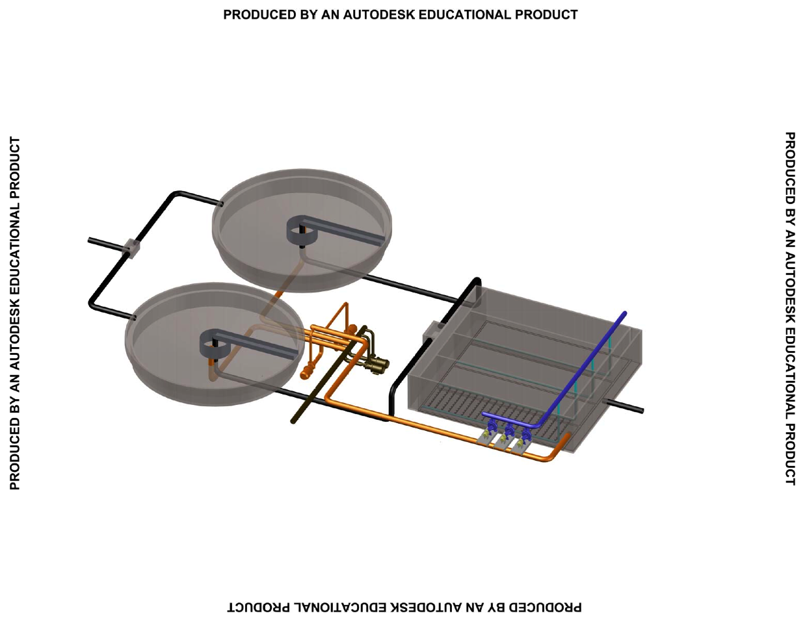

**4.1 Aeration Basin Effluent Pipes**

**Aeration basin effluent pipes are the water pipes connecting aeration basin and secondary clarifiers.**

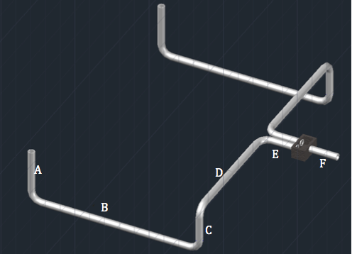

**X-sectional Area of Aeration basin effluent pipes, [ft2].** Aeration basin effluent pipes are sized based on water flow rate and velocity of water in pipe.

${Area}_{ABE}=\frac{Q_{air}}{{Velocity}_{ABE}}$ (for portion “F” shown in Figure)

${Area}_{ABE⁡}=\frac{Q_{air}}{2 × {Velocity}_{ABE}}$ (for portion “A”, “B”, “C”, “D”, “E”)

where ${Velocity}_{ABE}$ = Velocity of water in aeration basin effluent pipe [ft/s] = 3 [ft/s] (assumption)

**4.2 Return Activated Sludge (RAS) Pipes (orange)**

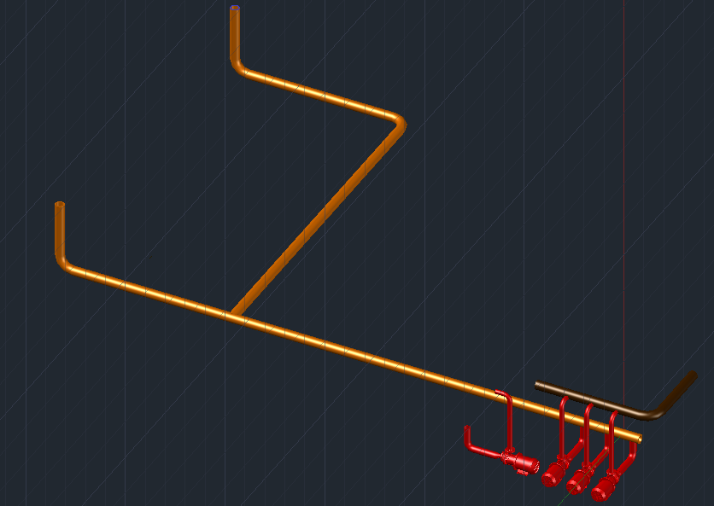

**X-sectional Area of RAS Pipes, [ft2].** RAS pipes are sized based on water flow rate and velocity of water in pipe.

${Area}_{RAS⁡}=\frac{Q_{RAS}}{{Velocity}_{RAS}}$

where ${Velocity}_{RAS}$ = Velocity of water in RAS pipe [ft/s] = 3 [ft/s] (assumption)

**4.3 Waste Activated Sludge (WAS) pipes (Brown)**

WAS pipes are very short and are thus neglected.

**4.4 Air Pipes**

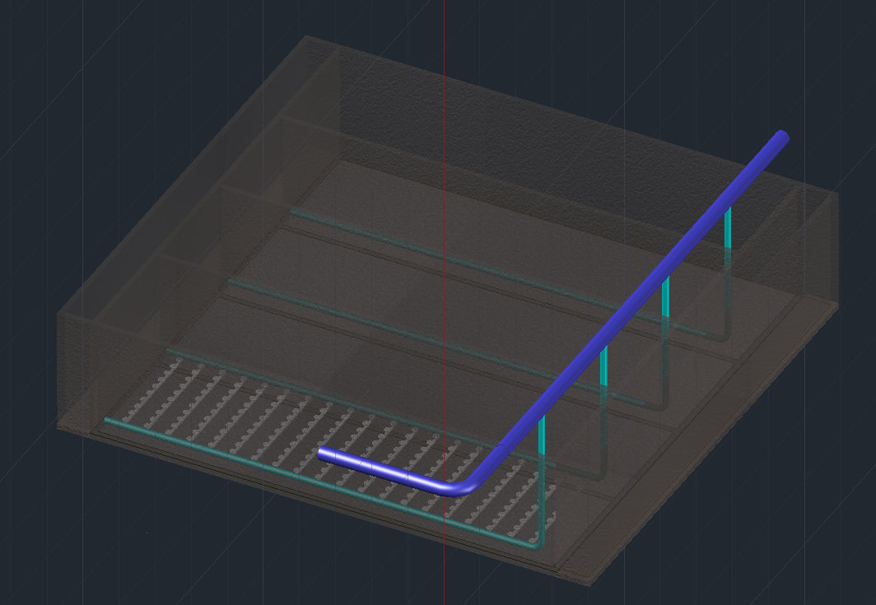

**4.4.1 Air Supply Manifold**

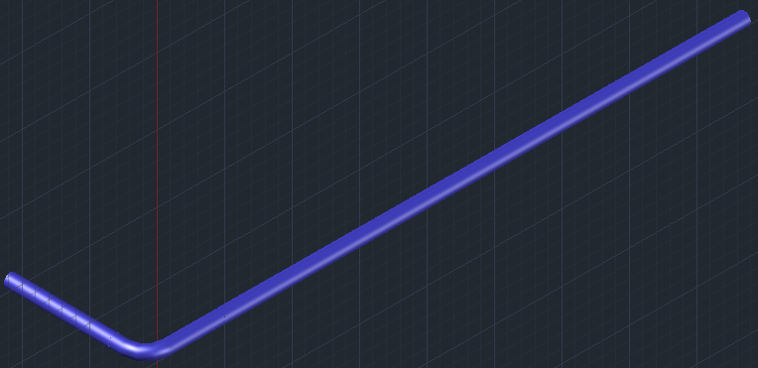

**Length of Air Supply Manifold, $L_{asm}$ [ft].** The length of air supply manifold is about the total width of the aeration basin of N trains.

$L_{asm}$ = $W_{N_train}$ + 30 ft

**X-sectional Area of Air Supply Manifold, [ft2].** Air supply manifold is sized based on airflow rate and velocity of air.

$${Area}_{asm}=\frac{Q_{air}}{{Velocity}_{asm}}$$

where ${Velocity}_{asm}$ = Velocity of air in air supply manifold [ft/s] = 3000 – 4000 fps

**4.4.2 Air Headers**

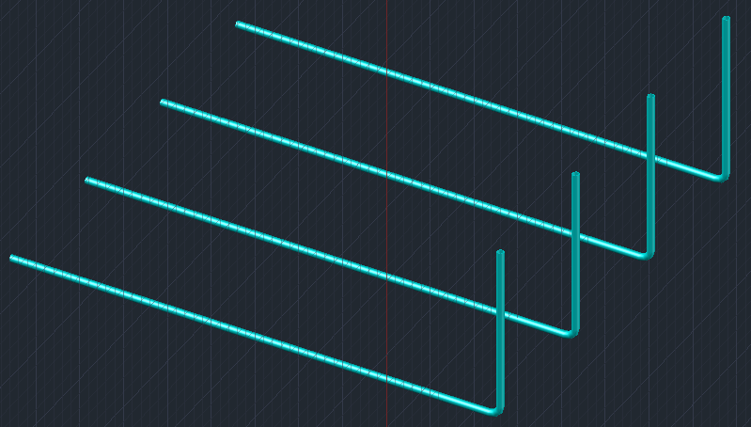

**Length of Single Air Header, $L_{ah_single}$ [ft].** The length of a single air header is about the sum of the length of the aeration basin and the height of the basin.

$$L_{ah_single}={Length}_{ab}+{Depth}_{ab}$$

**Length of Single Air Header, $L_{ah}$ [ft].**

$$L_{ah}=N × L_{ah_single}$$

**X-sectional Area of Air Header, [ft2].** Air header is sized based on airflow rate and velocity of air.

$${Area}_{ah}=\frac{Q_{air}}{N × {Velocity}_{ah}}$$

where ${Velocity}_{ah}$ = Velocity of air in air header [ft/s] = 3000 – 4000 fps

** All Pipes are sized using to ANSI Pipe Schedule Chart

|  |  |  |
| --- | --- | --- |
| Nominal Pipe Size | O.D. [in] | Pipe Thickness [in] (10s) |
| 1/8 | .405 | .049 |
| 1/4 | .540 | .065 |
| 3/8 | .675 | .065 |
| 1/2 | .840 | .083 |
| 3/4 | 1.050 | .083 |
| 1 | 1.315 | .109 |
| 1 1/4 | 1.660 | .109 |
| 1 1/2 | 1.900 | .109 |
| 2 | 2.375 | .109 |
| 2 1/2 | 2.875 | .120 |
| 3 | 3.500 | .120 |
| 3 1/2 | 4.000 | .120 |
| 4 | 4.500 | .120 |
| 4 1/2 | 5.000 |  |
| 5 | 5.563 | .134 |
| 6 | 6.625 | .134 |
| 7 | 7.625 |  |
| 8 | 8.625 | .148 |
| 9 | 9.625 |  |
| 10 | 10.75 | .165 |
| 11 | 11.750 |  |
| 12 | 12.750 | .180 |
| 14 | 14 | .250 |
| 16 | 16 | .250 |
| 18 | 18 | .250 |
| 20 | 20 | .250 |
| 22 | 22 | .250 |
| 24 | 24 | .250 |
| 26 | 26 | .312 |
| 28 | 28 | .312 |
| 30 | 30 | .312 |
| 32 | 32 | .312 |
| 34 | 34 | .344 |
| 36 | 36 | .312 |
| 42 | 42 | .312 |
| 48 | 48 | .312 |

**4.4.3 Air Diffuser Disks**

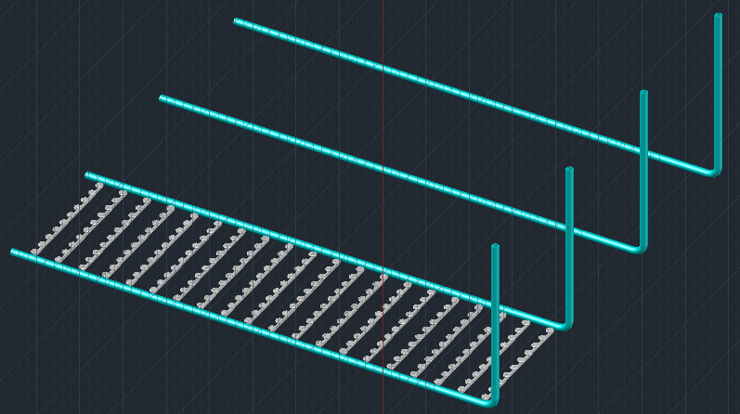

**Steps of Quantify Fine Bubble Diffuser Disks:**

**Spacing Between Each Diffuser Disk*, spacing [ft]*** = 2’-10”

**Number Of Diffuser Disks Per Line, numper_line** = *Widthab / spacing*

**Actual Oxygen Requirement, *AOR* [lb/min]** = *RO * 1.53098793 * 10-6*

**AOR to SOR Ratio for Fine Bubble Diffuser, *AOR_to_SOR*** *= 0.33*

**Standard Oxygen Requirement, *SOR* [kg/hr]** *= AOR / AOR_to_SOR*

***Depth Air Header Goes Under Water, Submergence* [ft] *=*** *Depthab*

**Oxygen Transfer Efficiency, *OTE*** *= Submergence * 0.02*

**Density of Air, *Densityair* [lb/scf]** = 0.0173 [lb/scf]

**Standard Cubic Feet of Air Required, *SCFMair* [scfm]** *= SOR / (Densityair * OTE)*

**Standard Cubic Feet of Air Each Fine Bubble Diffuser Disk Provides, *SCFMdisk* [scfm]** = 2 [scfm]

* *SCFMdisk* = 0.4 ~ 3.4 [scfm] for fine bubble diffuser in Metcalf & Eddy

**Total Number of Diffuser Disks, *numdiffuser*** *= SCFMair / SCFMdisk*

**Total Number of Diffuser Lines, *numline****= numdiffuser / N / numper_line*

**5. Pumping**

**5.1 Return Activated Sludge (RAS) Pumping**



**Total Dynamic Head, *TDHRAS* [ft].** Total dynamic head of RAS pumping can be calculated as follows:

*TDHRAS = Hts_RAS + Hsf_RAS  + Hdf_RAS + Hm_RAS*

The terms in the equation are explained below:

* **Suction Static Head, *Hss_RAS*[ft].** Suction static head of RAS pumping is the elevation difference between the centerline of the pump and the water level in the clarifier.

***Hss_RAS***= 6 [ft] (assumption)

* **Discharge Static Head, *Hds_RAS*[ft].** Discharge static head of RAS pumping is the elevation difference between the centerline of the pump and the water level in the aeration basin.

*Hds_RAS* = 18 + ${Depth}_{ab}$ [ft] (assumption)

Where ${Depth}_{ab}$ = Depth of aeration basin [ft]

* **Total Static Head, *Hts_RAS*[ft].** The total static head of RAS pumping can be calculated by:

*Hts_RAS = Hds_RAS - Hss_RAS*

* **Suction Friction Head, *Hsf_RAS* [ft].** Suction friction head can be estimated using the Hazen- Williams equation. Suction friction head of permeating pumping refers to the friction loss caused in the RAS pipes.

*Hsf_RAS = 3.02 Lsf_RASVelocityRAS1.85 C-1.85 (DRAS /12)-1.17*

* Assume Hazen-Williams constant *C* = 100

* **Discharge Friction Head, *Hdf_RAS* [ft].** Discharge friction head of permeate pumping refers to the friction loss caused in the discharge pipe, which is the permeate collector.

*Hdf_RAS = 3.02 LRAS VelocityRAS1.85 C-1.85 (DRAS /12)-1.17*

* Assume Hazen-Williams constant *C* = 100

* **Minor losses, *Hm_RAS*[ft].** Minor losses include the losses in 90-degree bends, tees, exit, and entrance, and are calculated using equations below.

*Hm_RAS = (K $×$ VelocityRAS2 /2g)*



* + 90-degree bend: *K1* = 0.30

*Hm_RAS_1 = (Nclfr + 1) (K1 VelocityRAS2 /2g)*

* + Tees: *K2* = 0.30

*Hm_RAS_2 = (Nclfr +2 Npump_RAS) (K2 VelocityRAS2 /2g)*

* + Exit loss*: K3* = 1.0

*Hm_RAS_3 = 1 (K3 VelocityRAS2 /2g)*

* + Entrance loss: *K4* = 0.5

*Hm_RAS_4 = Nclf*r *(K4 VelocityRAS2 /2g)*

where *Nclfr* = number of clarifiers

*Npump_RAS* = number of RAS pumps

**5.3 Waste Activated Sludge (WAS) Pumping**



**Total Dynamic Head, *TDHWAS* [ft].** Total dynamic head of WAS pumping can be calculated by:

*TDHWAS = Hts_WAS + Hsf_WAS +Hdf_WAS + Hm_WAS*

The terms in the equation are explained below:

* **Suction Static Head, *Hss_WAS* [ft]** Suction static head of WAS pumping is the elevation difference between the centerline of the pump and the bottom of clarifier.

***Hss_WAS***= 6 [ft] (assumption)

* **Discharge Static Head, *Hds_WAS*[ft].** Discharge static head of WAS pumping is the elevation difference between the centerline of the WAS pump and where sludge is discharged.

*Hds_WAS*= 20 [ft]

* **Total Static Head, *Hts_WAS*[ft].** The total static head of WAS pumping is calculated by:

*Hts_WAS = Hds_WAS - Hss_WAS*

* **Suction Friction Head, *Hsf_WAS*[ft].** Suction friction head can be estimated using the Hazen- Williams equation. Suction friction head of permeating pumping refers to the friction loss caused in the WAS pipes.

*Hsf_WAS = 3.02 LWAS VelocityWAS1.85 C-1.85 (DWAS /12)-1.17*

* Assume Hazen-Williams constant *C* = 100

* **Discharge Friction Head, *Hdf_WAS* [ft].** Discharge friction head of permeate pumping refers to the friction loss caused in the discharge pipe, which is the permeate collector.

*Hdf_WAS = 3.02 Ldf_WASVelocityWAS1.85 C-1.85 (DWAS /12)-1.17*

* Assume Hazen-Williams constant *C* = 100

* **Minor losses, *Hm_WAS* [ft].** Minor losses include the losses in 90-degree bends, tees, exit, and entrance, and are calculated using equations below.

*Hm_WAS = (K $×$ VelocityWAS2 /2g)*

**

* + 90-degree bend: *K1* = 0.30

*Hm_WAS_1 = (Nclfr + 1) (K1 VelocityWAS2 /2g)*

* + Tees: K2 = 0.30

*Hm_WAS_2 = (Nclfr +2 Npump_WAS) (K2 VelocityWAS2 /2g)*

* + Exit loss: K3 = 1.0

*Hm_WAS_3 = 1 (K3 VelocityWAS2 /2g)*

* + Entrance loss: *K4* = 0.5

*Hm_WAS_4 = Nclfr*  *(K4 VelocityWAS2 /2g)*

where *Nclfr*is the number of clarifiers

*Npump_WAS* = number of WAS pumps

**5.4 Rotating Sludge Collector Rakes**

The electricity consumed by the rotating mechanisms in the clarifier is estimated to be 1.5 bhp.

**5.5 Electricity Consumption**

**Brake Horsepower, BHP.** BHP is the amount of horsepower required to drive the pump and can be calculated by the equation below:

$$BHP= \frac{ flow rate × Head}{3960 × Pump Efficiency}$$

where flow rate (gpm) and head (ft) are the x-axis and y-axis respectively on a pump curve.

**Energy input, Einput (Kw).** The amount of energy input into the motor of the pump can be calculated as:

$$E_{input}= \frac{ BHP × 0.746}{Motor Efficiency}$$

$Motor Efficiency$* is assumed to be 70%

**6. Aeration**

$$BHP=\frac{Adiabatic Horsepower}{Mechanical Efficiency}=\frac{SCFM\left(.23\right)\left[{\left(\frac{14.7+P}{14.7}\right)}^{0.283}-1.0\right]}{Mechanical Efficiency}$$



where

SCFM = Standard Cubic Feet Per Minute (flow rate)

P = Blower discharge pressure in PSIG (gage pressure)

**Calculation of Pressure, P [psig]**

Specific Gravity, SG = 1

P = 0.434 * (Hwater + H_f_asm + H_f_ah + H_f_diff) * SG

Where H_water = water pressure head [ft] = 19 [ft]

H_f_asm = Friction Head in Air Supply Manifold [ft]

H_f_ah = Friction Head in Air Header [ft]

H_f_diff = Friction Head across Air Diffuser Disks [ft]

**Calculation of headlosses:**

* Friction loss in air supply manifold, H_f_asm [ft] (using Darcy-Weisbach Eq.)

H_f_asm = f_asm * L_asm / (ID_asm/12) * h_v_asm

Where f_asm = friction factor [ft]

= 0.029 * (ID_asm/12)0.027 / (SCFM_air)0.148

h_v_asm = velocity head [ft]

= VEL_asm 2 / 64.4

ID_asm = Inner diameter of air supply manifold [ft]

SCFM_air = Total air requirement [scfm]

L_asm  = Length of air supply manifold [ft]

* Friction loss in air headers (using Darcy-Weisbach Eq.)

H_f_ah = f_ah * L_ah / (ID_ah/12) * h_v_ah

Where f_ah = 0.029 * (ID_ah/12)0.027 / (Q_air_ah)0.148

h_v_ah = VEL_ah2 / 64.4

ID_asm = Inner diameter of air header [ft]

Q_air_ah = air flow rate in air header = SCFM_air / NR_BLO

NR_BLO = Number of blowers in duty

L_ah  = Length of air header [ft]